St. Francis Institute of Technology, Mumbai-400 103

**Department Of Information Technology**

A.Y. 2024-2025

Class: TE-ITA/B, Semester: V

Subject: **DevOps Lab**

**Experiment – 6: To understand master-slave architecture and scale your Jenkins standalone implementation by implementing slave nodes.**

1. **Aim:** To understand master-slave architecture and scale your Jenkins standalone implementation by implementing slave nodes
2. **Objectives:** Aim of this experiment is that, the students will be able to do

* Jenkins management
* Adding a slave node to Jenkins

1. **Outcomes:** After study of this experiment, the students will be able

* To understand the importance of Jenkins to Build and deploy Software

Applications on server environment.

1. **Prerequisite:** Knowledge of Computer Networks concept of Master-slave architecture
2. **Requirements:** Jenkins,JDK, python,Personal Computer, Windows operating system, browser, Internet Connection, Microsoft Word.
3. **Pre-Experiment Exercise:**

**Brief Theory:** Refer shared material

1. **Laboratory Exercise**
   * + 1. **Procedure:**

**a. Answer the following:**

* Explain the architecture of Jenkins with diagram.
* Explain the distributed architecture of Jenkins with diagram

**b**. **Execute following (Refer the shared material) and attach screenshots:**

* Create a slave node and connect it to master
* Use an existing project or a new project to run in the slave node
* Apply cron command on a project

1. **Post-Experiments Exercise**
2. **Extended Theory:**

Nil

1. **Questions:**

* What are the ways to configure Jenkins node agent to communicate with Jenkins master?
* Which architecture is recommended for a scalable Jenkins environment?

1. **Conclusion:**

* Write what was performed in the experiment.
* Write the significance of the topic studied in the experiment.

1. **References:**

<https://jenkins.io/doc/>

<https://www.slideshare.net/abediaz/introduction-to-jenkins>

https://www.studytonight.com/jenkins/jenkins-master-slave-configuration

<https://www.edureka.co/blog/jenkins-master-and-slave-architecture-a-complete-guide/>

**7. Laboratory Exercise**

* + - 1. **Procedure:**

**b**. **Execute following (Refer the shared material) and attach screenshots:**

* Create a slave node and connect it to master

Create a Slave Node:

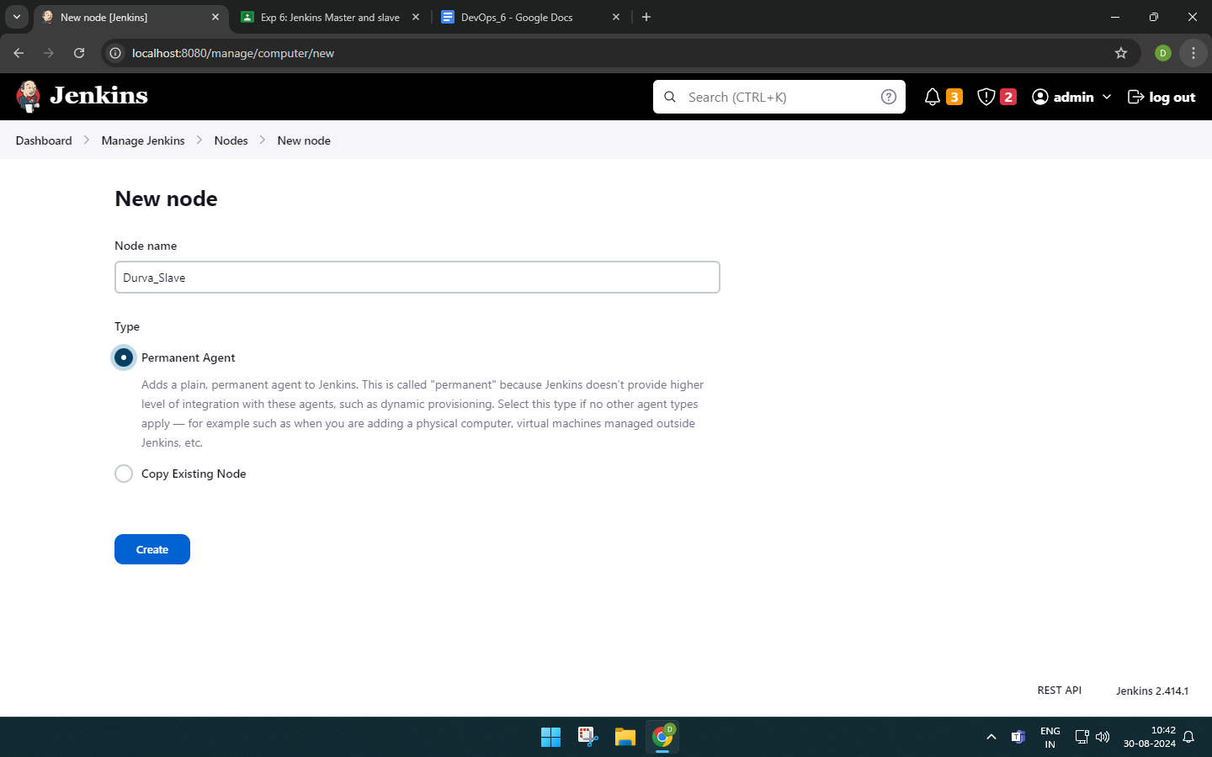

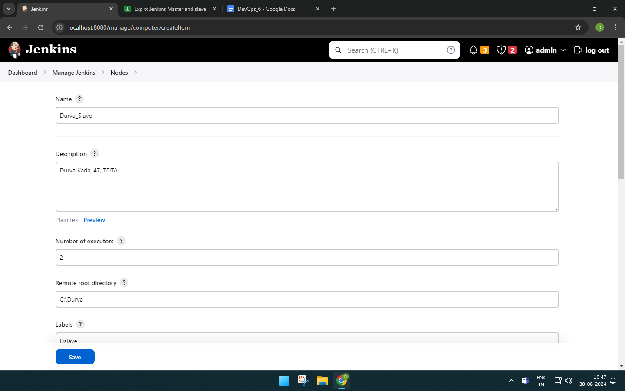

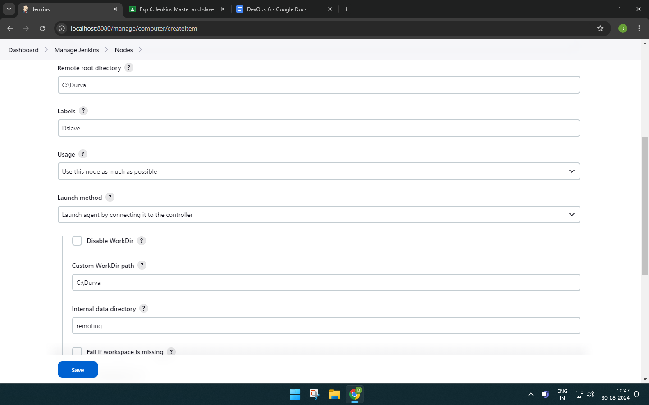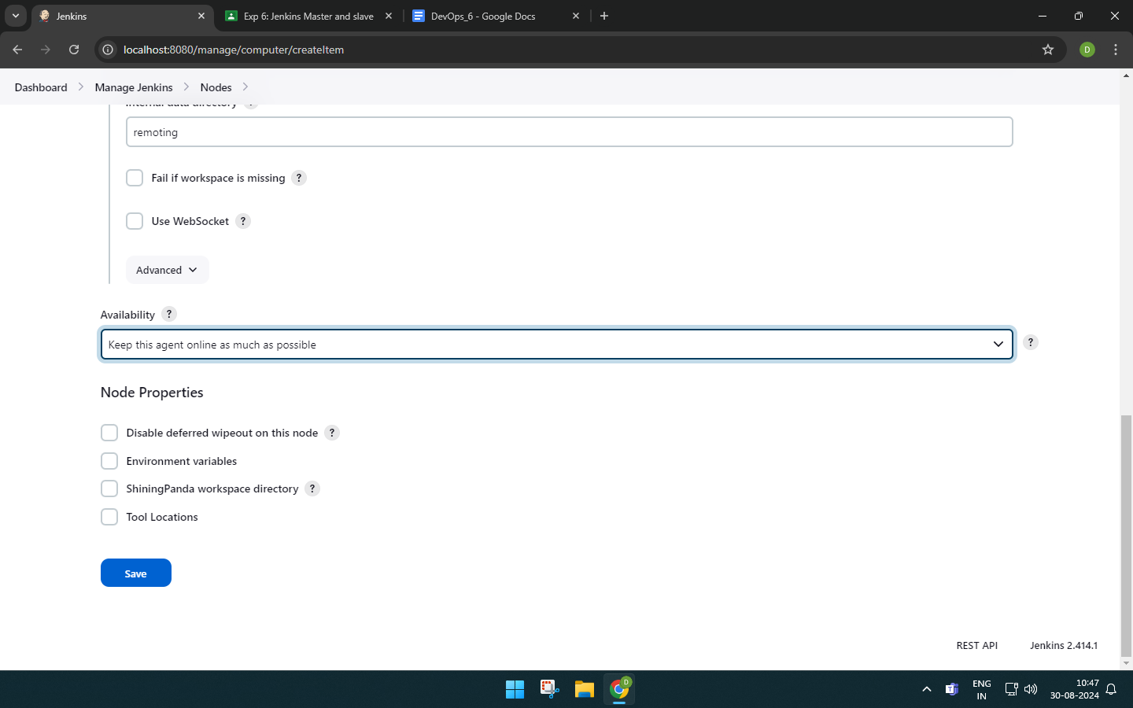

Now the slave node is created but it is disabled.

enabling the tcp/ip port for the slave through manage jenkins-> security

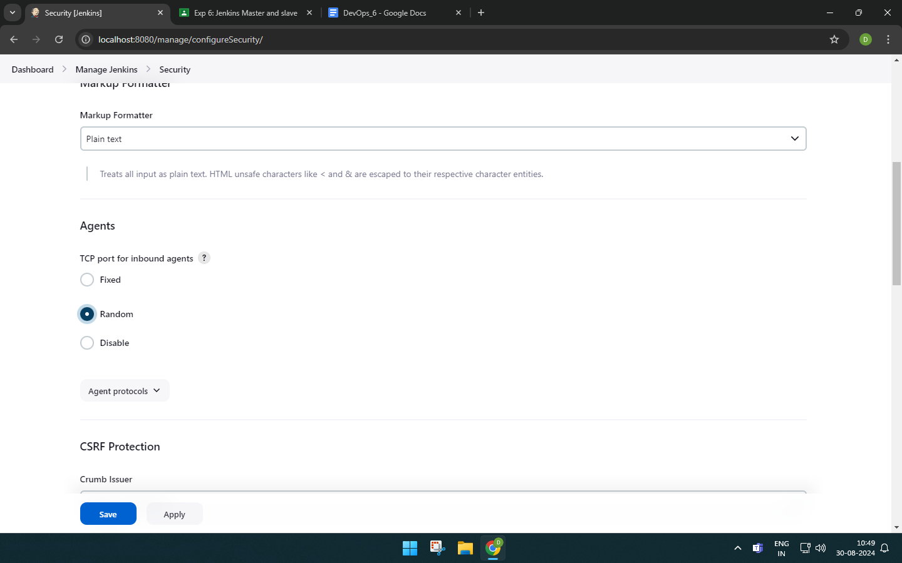

Now, take the code in the windows section and paste it in the command prompt.

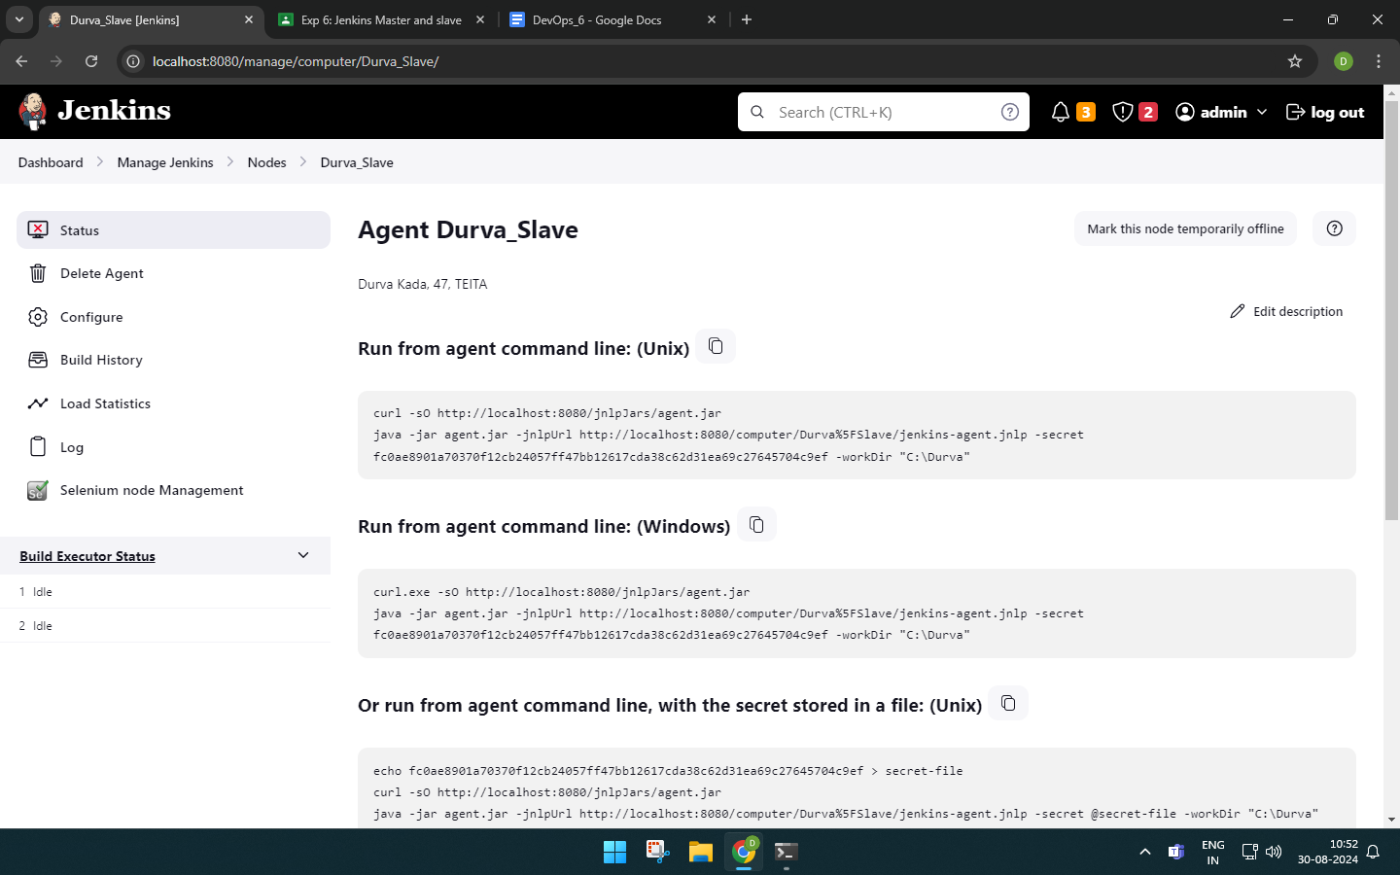

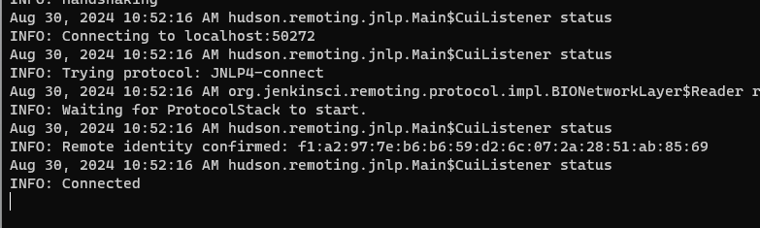

The java executable for the slave is connected for the master.



We can see on Jenkins that the node is connected.

Now, in the slave node section click the option to make it temporarily offline and enter any reason. We can see that the node is now offline.

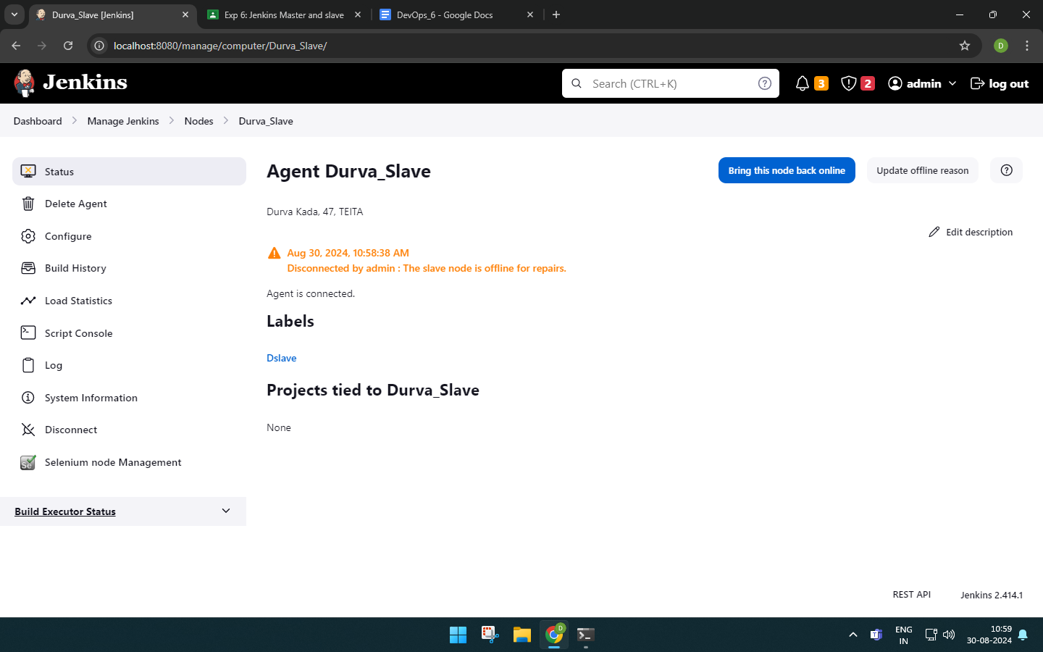

We can bring it online again.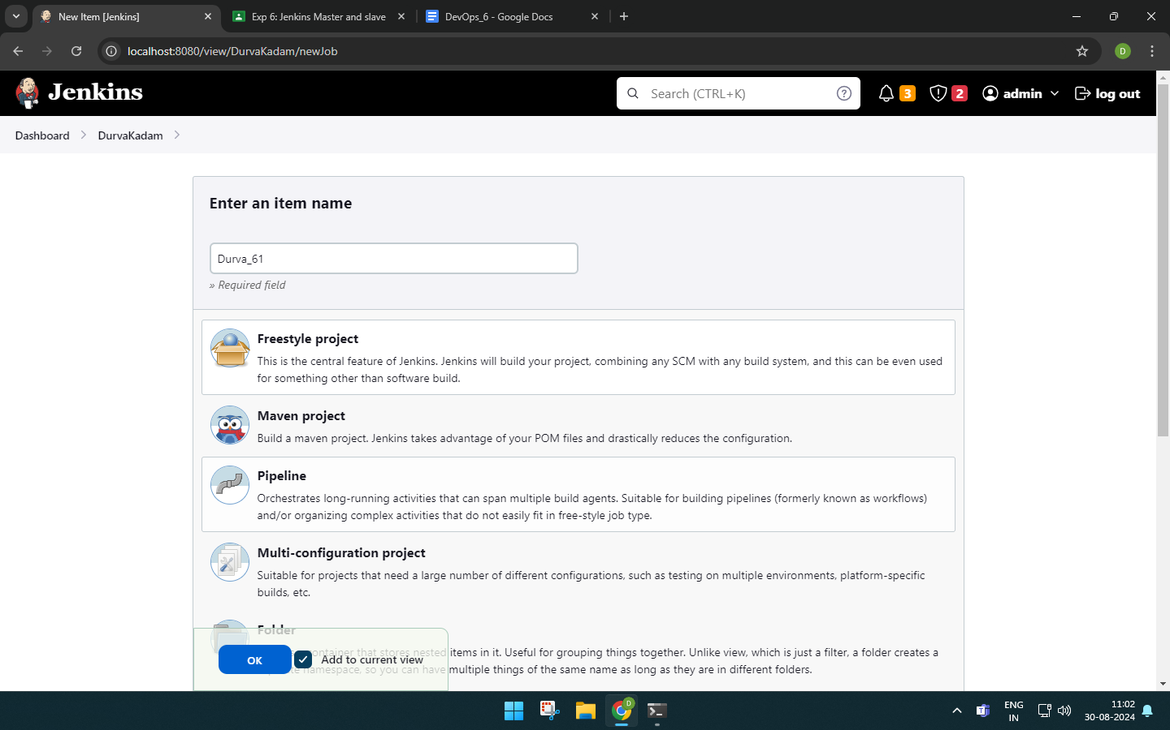

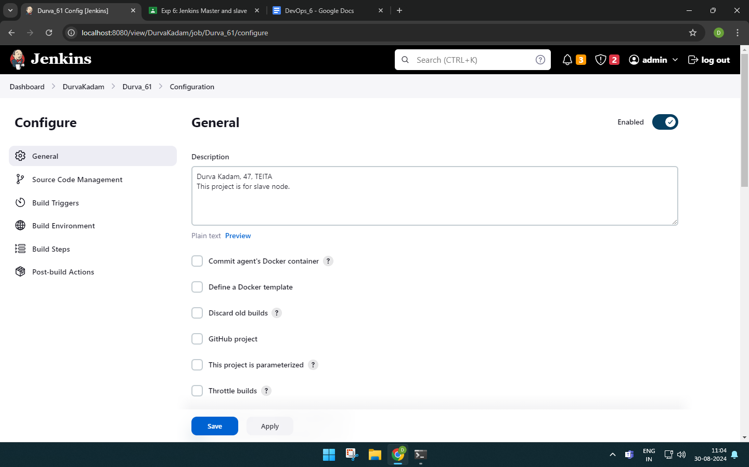

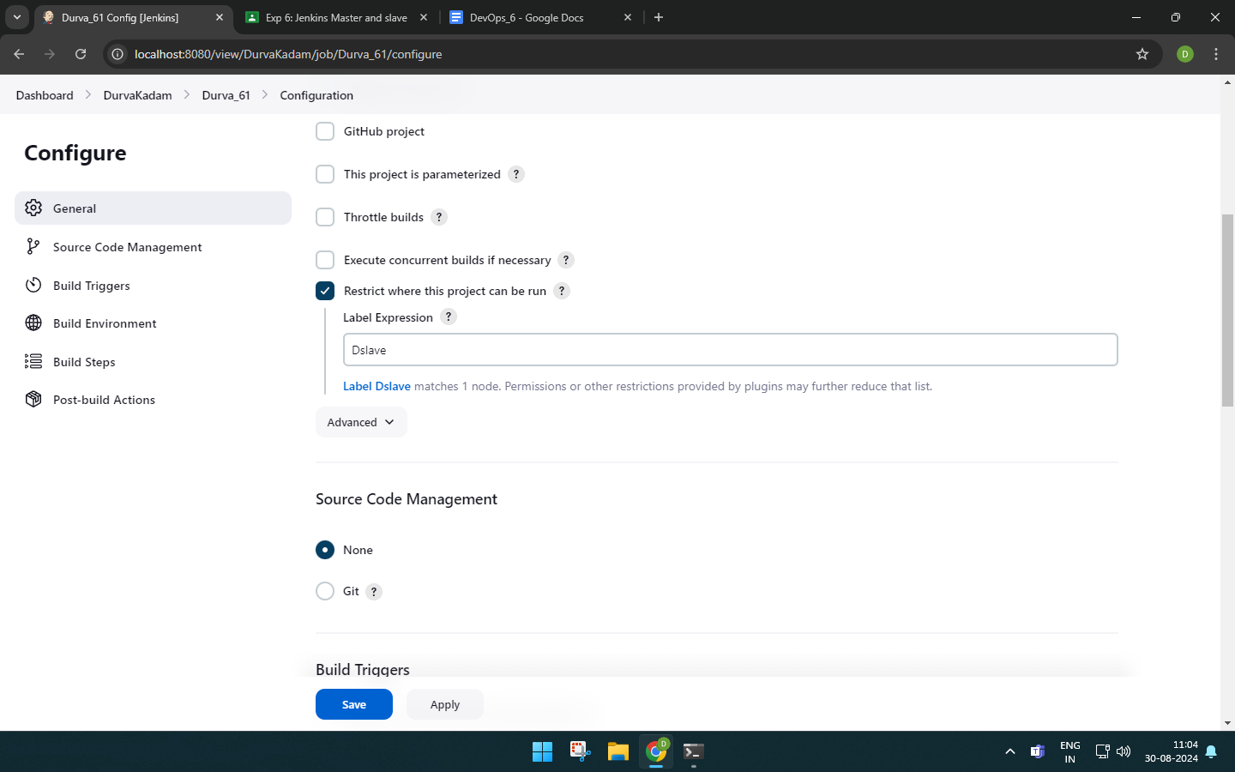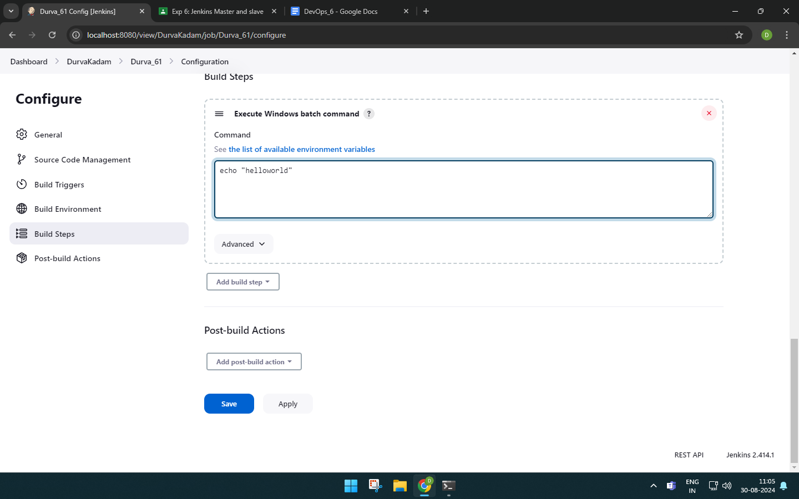

The output is successful and we get a hyperlink to the slave.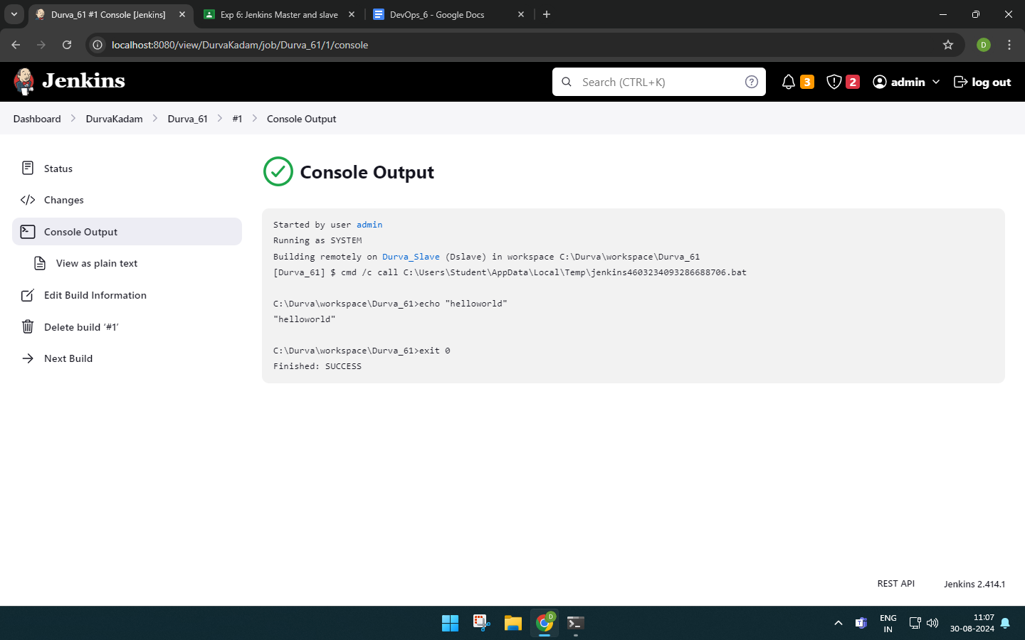List of projects assigned to the slave.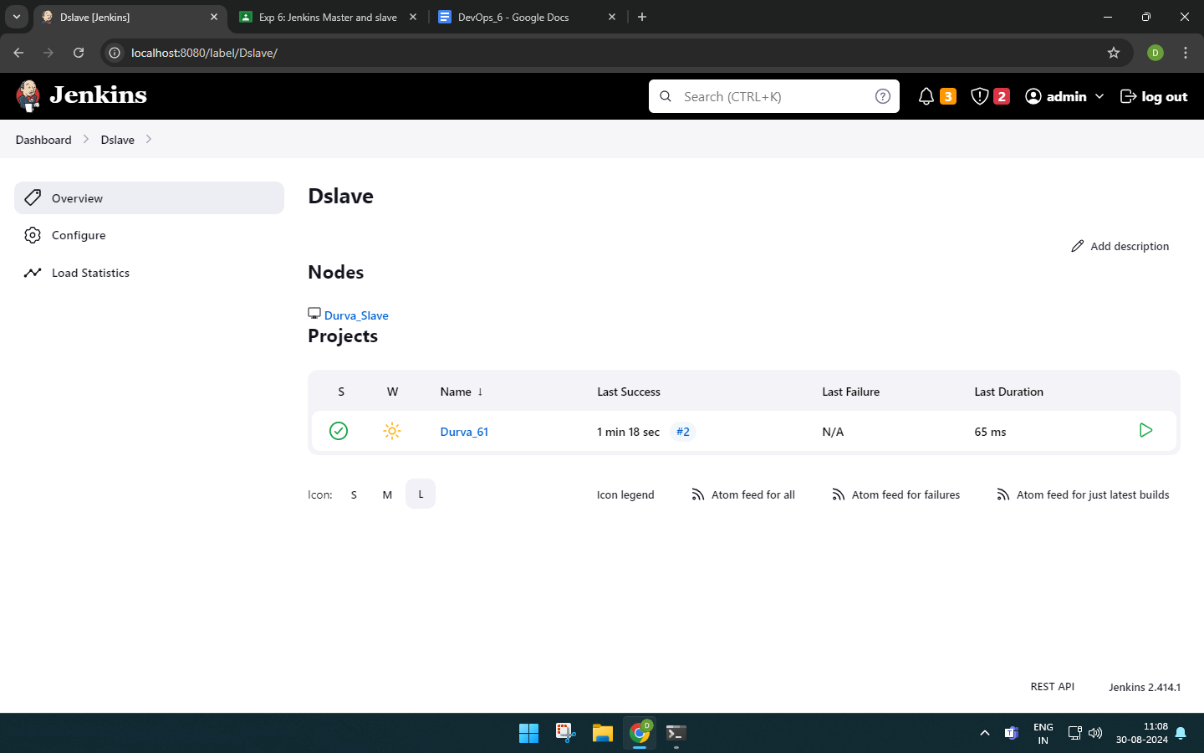

Now, we use the cron command to build our project every 5 minutes.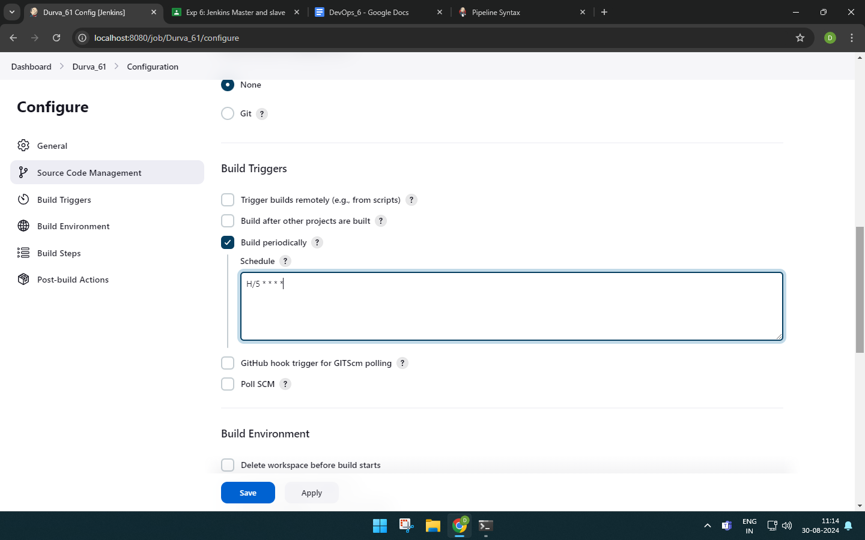

We can see that the builds are executed every 5 minutes because of the cron commands.

